2021 Awards of the Division of Analytical Chemistry

EuChemS Division of Analytical Chemistry (DAC) presented two awards for 2021, the DAC-EuChemS Award to Professor Aldo Roda and the Robert Kellner Lecture (RKL) to Professor Karin Faulds at the DAC-EuChemS Webinar on 16 September 2021.
The video “Webinar 2021 DAC-EuChemS Lectures Awardees” is available now. Enjoy in excellent lectures:

DAC-EuChemS Award
Prof. Aldo Roda (Alma Laurea University of Bologna): “Recent Advances and Challenges in bio-chemiluminescence based biosensors”

Rober Kellner Lecture
Prof. Karen Faulds (University of Strathclyde): “Development of SERS and SESORRS for Multiplexed Bioanalysis”
PRESS RELEASE: Springer sponsors two award lectures in analytical chemistry

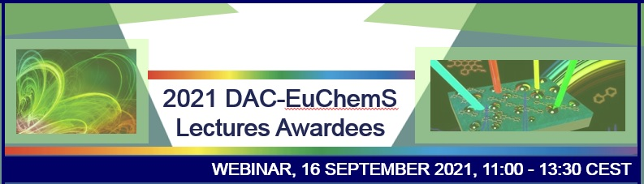
To read more ⇒⇒ Programme and Speakers

EuChemS at #GWB2021

First EuChemS @Global Women’s Breakfast 2021

EuChemS organised its first Global Women’s Breakfast event as an interactive webinar on 9 February 2021, which was a part of the global initiative of IUPAC.
You can watch the EuChemS @Global Women’s Breakfast 2021 webinar recording here.

