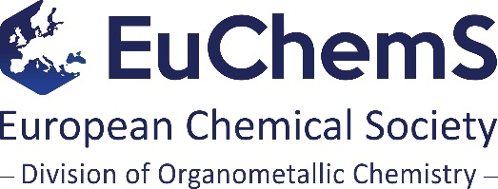

European Prize for Organometallic Chemistry
1. The Prize
1.1 The EuChemS Division of Organometallic Chemistry (DOM) wishes to award a European Prize for Organometallic Chemistry.
1.2 The European Prize for Organometallic Chemistry will be awarded biennially to coincide with the European Conference on Organometallic Chemistry (EuCOMC).
1.3 The Prize will be awarded for a single piece of outstanding work or for a body of outstanding work primarily done in member countries of the European Union, including Norway, Switzerland, Turkey and Israel. Nominations for work that has shaped, or will shape, the future of the subject will be particularly welcome.
1.4 The Prize will have a monetary value of €5000.
1.5 It is a condition of the award that the recipient will deliver a plenary lecture at the next EuCOMC. The prize winner’s travel and subsistence expenses in connection with the attendance of EuCOMC will be reimbursed, up to a limit of €750.

2. Nomination procedure
2.1 By 15 October of the year preceding the award, the national representatives of DOM will elicit nominations from the relevant bodies of their national chemical societies. This will in most cases imply writing to the Chairs of the Organic and the Inorganic (or Coordination Chemistry) Divisions, or to the national Division of Organometallic Chemistry, as appropriate.
2.2 The European Prize for Organometallic Chemistry may be advertised on the EuChemS website, as well as the websites of national member societies.
2.3 Each national division may submit one name to the Chair of DOM, either directly or via their respective national DOM representative.
2.4 Nominations must be made using the appropriate nominations form and reach the Chair of DOM no later than four months after the initial invitations (at or around 20 February of the following year).
2.5 There will be a selection committee of seven persons, consisting of the Chair of DOM plus representatives from six different national member societies. If circumstances arise that could reasonably be construed as constituting a conflict of interest, the Chair will appoint a deputy to take his/her place.
2.6 The selection will be based solely on scientific merit and international standing of the candidate in the area of organometallic chemistry.
2.7 Having served on the selection committee, three of the six appointed national representatives will continue to serve once more for the subsequent prize selection. They will be joined by three newly appointed representatives from national member societies who have not previously been involved in the selection process.
2.8 No representative of a national member society may serve on the selection committee more than twice, until all member countries have been involved in the selection. Once that has happened, a new cycle of appointments will start.
2.9 The prize will be announced in April of the year of the award.

European Prize for Organometallic Chemistry 2019, timetable:
DOM representative contacts divisions of national member societies asking for nominations | 15 October 2018
DOM Chair appoints selection committee | Jan/Feb 2019
DOM representative receives nominations and forwards to Chair of DOM | 26 February 2019
DOM selection committee considers nominations | March 2019
Prize award announced | April 2019
EuCOMC and plenary prize lecture | June 2019

