First European Prize for Organometallic Chemistry
Awarded to Professor Malcom L.H. Green

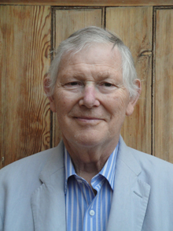
The first European Prize for Organometallic Chemistry was awarded to Professor Malcom L. H. Green, Oxford University, UK.
This monetary prize of €5000 was created by the EuCheMS´ Division of Organometallic Chemistry (DOM). This prize is to be awarded every two years ”for a single piece of outstanding work or for a body of outstanding work primarily done in Europe, including Turkey and Israel”.
Malcolm L. H. Green, Emeritus Professor at Oxford University, UK has received the Prize for his outstanding contributions to the field of organometallic chemistry including pioneering studies of molybdenocene and tungstenocene systems, novel methods for molecular inorganic synthesis, for catalysis and for carbon materials as well as fundamental studies of alpha- and beta-hydrogen migratory insertions and C-H bond activations – the well-established term agostic interaction was conceived by professor Green.
For more information on the scientific achievements of the 2015 winner, please consult http://research.chem.ox.ac.uk/malcolm-green.aspx
The Prize ceremony and a lecture by the winner took place at the 21st European Conference on Organometallic Chemistry in Bratislava.

