European Prize for Organometallic Chemistry 2017
Awarded to Professor David Milstein

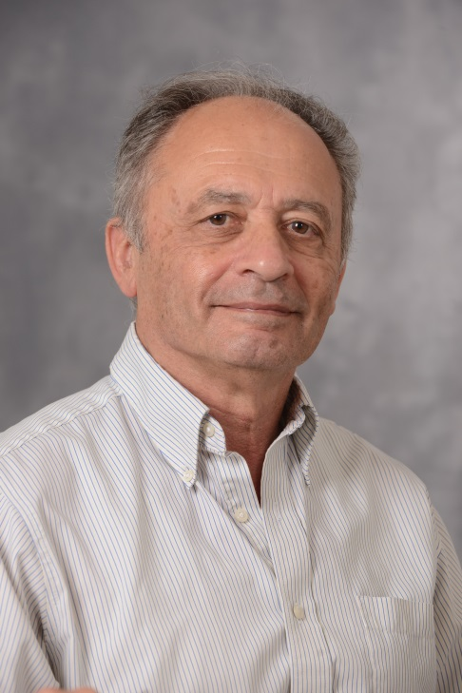
The European Prize for Organometallic Chemistry 2017 was awarded to Professor David Milstein, The Weizmann Institute of Science, Israel.
This monetary prize of €5000 was created by the EuCheMS´ Division of Organometallic Chemistry (DOM). This prize is to be be awarded every two years ”for a single piece of outstanding work or for a body of outstanding work primarily done in member countries of the European Union, including Norway, Switzerland, Turkey and Israel”.
David Milstein, Israel Matz Professor of Organic Chemistry at The Weizmann Institute of Science, Israel has received the Prize for his seminal work in several areas of organometallic chemistry during the last four decades. He has shown, many times for the first time, how the insertion of transition metal complexes into chemical bonds can activate them towards uncommon transformations and form the basis for the design of new catalytic reactions and new synthetic methodology. He has also developed a number of new transformational homogeneous catalysis reactions many times based on metal-ligand cooperation.
For more information on the scientific achievements of the 2017 winner, please consult http://www.weizmann.ac.il/Organic_Chemistry/milstein/
The Prize ceremony and a lecture by the winner will take place at the 22nd EuCheMS International Organometallic Conference in Amsterdam.

